# Question-1:

Assignment –3

# Create a Bucket in IBM object storage

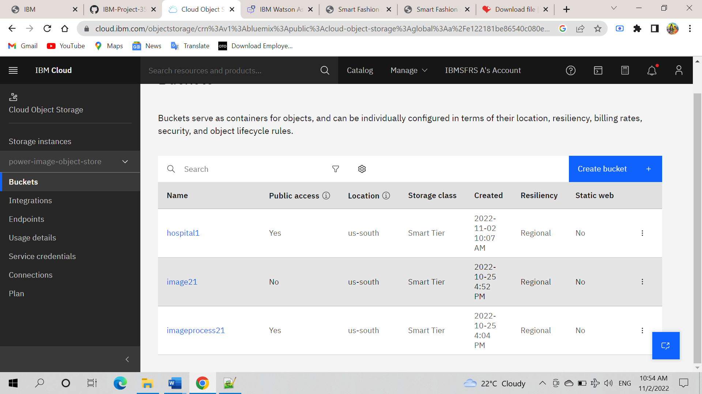

**Question-2:**

# Upload an 5 images to ibm object storage and make it public. Write html code to displaying all the 5 images.

**Solution:**

Html code:

<!DOCTYPE html>

<html lang="en">

<head>

<meta charset="UTF-8">

<meta http-equiv="X-UA-Compatible" content="IE=edge">

<meta name="viewport" content="width=device-width, initial-scale=1.0">

<title>Smart Fashion shop </title>

<link rel="stylesheet" href="https://imagebucket-vk.s3.ap.cloud-object-storage.appdomain.cloud/style.css">

</head>

<body>

<h1>SHIVAM Hospital !!!</h1>

<div>

<img src="https://hospital1.s3.us-south.cloud-object-storage.appdomain.cloud/h1.jpg"

alt="Dress" srcset="">

<img src="https://hospital1.s3.us-south.cloud-object-storage.appdomain.cloud/h2.jpg"

alt="Dress" srcset="">

<img src="https://hospital1.s3.us-south.cloud-object-storage.appdomain.cloud/h3.jpg"

alt="Dress" srcset="">

<img src="https://hospital1.s3.us-south.cloud-object-storage.appdomain.cloud/h4.jpg"

alt="Dress" srcset="">

<img src="https://hospital1.s3.us-south.cloud-object-storage.appdomain.cloud/h5.jpg"

alt="Dress" srcset="">

</div></div>

</body>

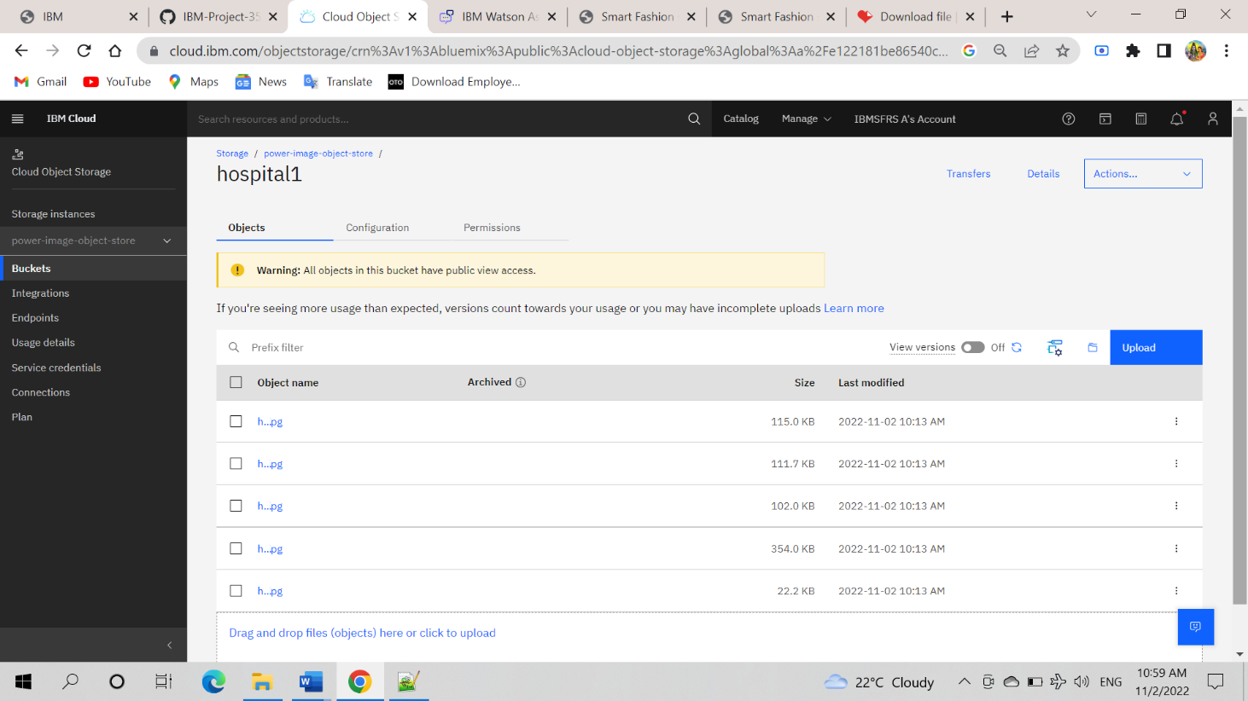</html>

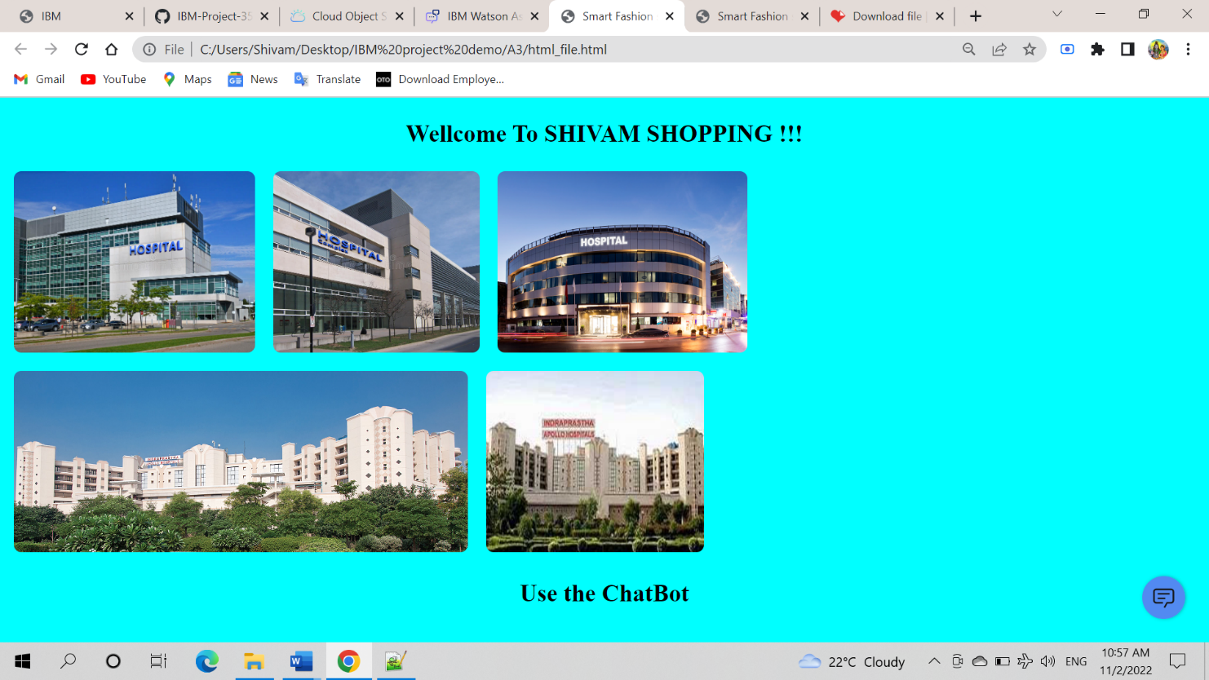

# Question-3:

**Upload a CSS page to the object storage and use the same page in your html code.**

# Solution:

style.CSS uploaded to the object storage and used the same page in html code.

body {

background-color: aqua;

display: flex;

align-items: center;

justify-content: center;

flex-direction: column;

}

img {

height: 240px;

border-radius: 10px;

margin: 10px;



# Question-4:

**Design a Chatbot using IBM Watson assistant for hospital. Ex: User come the query to know the branches for that hospital in your city.**

# Solution:

URL for: [https://web-](https://web-chat.global.assistant.watson.appdomain.cloud/preview.html?backgroundImageURL=https%3A%2F%2Fau-syd.assistant.watson.cloud.ibm.com%2Fpublic%2Fimages%2Fupx-0516420a-a54c-4626-b459-481c71f5ac41%3A%3A512d2748-7659-4d70-ba79-81fcedac9d3b&integrationID=0b305951-d464-4f72-9cc7-938932287427&region=au-syd&serviceInstanceID=0516420a-a54c-4626-b459-481c71f5ac41) [chat.global.assistant.watson.appdomain.cloud/preview.html?backgroundImageUR](https://web-chat.global.assistant.watson.appdomain.cloud/preview.html?backgroundImageURL=https%3A%2F%2Fau-syd.assistant.watson.cloud.ibm.com%2Fpublic%2Fimages%2Fupx-0516420a-a54c-4626-b459-481c71f5ac41%3A%3A512d2748-7659-4d70-ba79-81fcedac9d3b&integrationID=0b305951-d464-4f72-9cc7-938932287427&region=au-syd&serviceInstanceID=0516420a-a54c-4626-b459-481c71f5ac41) [L=https%3A%2F%2Fau-](https://web-chat.global.assistant.watson.appdomain.cloud/preview.html?backgroundImageURL=https%3A%2F%2Fau-syd.assistant.watson.cloud.ibm.com%2Fpublic%2Fimages%2Fupx-0516420a-a54c-4626-b459-481c71f5ac41%3A%3A512d2748-7659-4d70-ba79-81fcedac9d3b&integrationID=0b305951-d464-4f72-9cc7-938932287427&region=au-syd&serviceInstanceID=0516420a-a54c-4626-b459-481c71f5ac41) [syd.assistant.watson.cloud.ibm.com%2Fpublic%2Fimages%2Fupx-0516420a-](https://web-chat.global.assistant.watson.appdomain.cloud/preview.html?backgroundImageURL=https%3A%2F%2Fau-syd.assistant.watson.cloud.ibm.com%2Fpublic%2Fimages%2Fupx-0516420a-a54c-4626-b459-481c71f5ac41%3A%3A512d2748-7659-4d70-ba79-81fcedac9d3b&integrationID=0b305951-d464-4f72-9cc7-938932287427&region=au-syd&serviceInstanceID=0516420a-a54c-4626-b459-481c71f5ac41) [a54c-4626-b459-481c71f5ac41%3A%3A512d2748-7659-4d70-ba79-](https://web-chat.global.assistant.watson.appdomain.cloud/preview.html?backgroundImageURL=https%3A%2F%2Fau-syd.assistant.watson.cloud.ibm.com%2Fpublic%2Fimages%2Fupx-0516420a-a54c-4626-b459-481c71f5ac41%3A%3A512d2748-7659-4d70-ba79-81fcedac9d3b&integrationID=0b305951-d464-4f72-9cc7-938932287427&region=au-syd&serviceInstanceID=0516420a-a54c-4626-b459-481c71f5ac41)

[81fcedac9d3b&integrationID=0b305951-d464-4f72-9cc7-](https://web-chat.global.assistant.watson.appdomain.cloud/preview.html?backgroundImageURL=https%3A%2F%2Fau-syd.assistant.watson.cloud.ibm.com%2Fpublic%2Fimages%2Fupx-0516420a-a54c-4626-b459-481c71f5ac41%3A%3A512d2748-7659-4d70-ba79-81fcedac9d3b&integrationID=0b305951-d464-4f72-9cc7-938932287427&region=au-syd&serviceInstanceID=0516420a-a54c-4626-b459-481c71f5ac41) [938932287427&region=au-syd&serviceInstanceID=0516420a-a54c-4626-b459-](https://web-chat.global.assistant.watson.appdomain.cloud/preview.html?backgroundImageURL=https%3A%2F%2Fau-syd.assistant.watson.cloud.ibm.com%2Fpublic%2Fimages%2Fupx-0516420a-a54c-4626-b459-481c71f5ac41%3A%3A512d2748-7659-4d70-ba79-81fcedac9d3b&integrationID=0b305951-d464-4f72-9cc7-938932287427&region=au-syd&serviceInstanceID=0516420a-a54c-4626-b459-481c71f5ac41) [481c71f5ac41](https://web-chat.global.assistant.watson.appdomain.cloud/preview.html?backgroundImageURL=https%3A%2F%2Fau-syd.assistant.watson.cloud.ibm.com%2Fpublic%2Fimages%2Fupx-0516420a-a54c-4626-b459-481c71f5ac41%3A%3A512d2748-7659-4d70-ba79-81fcedac9d3b&integrationID=0b305951-d464-4f72-9cc7-938932287427&region=au-syd&serviceInstanceID=0516420a-a54c-4626-b459-481c71f5ac41)

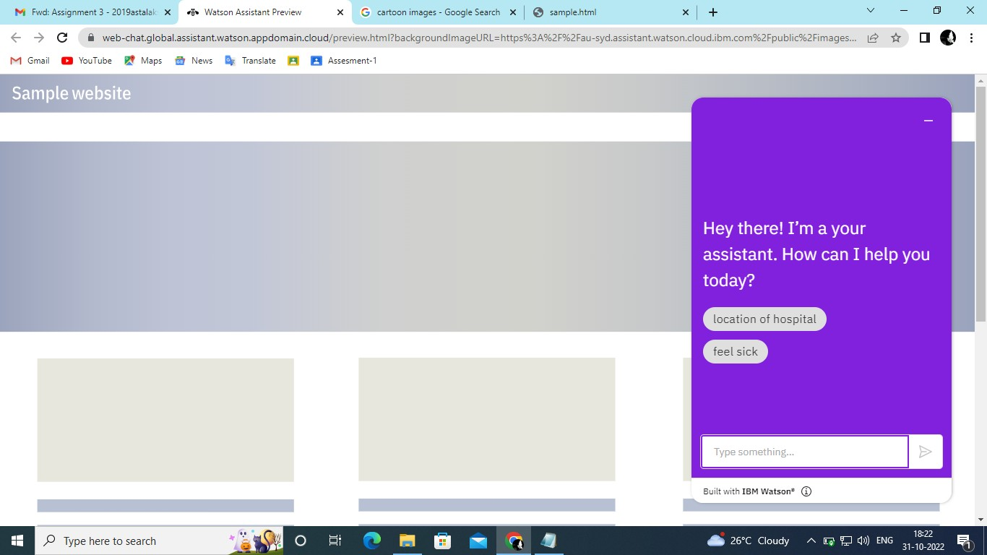

# Question-5:

**Create Watson assistant service with 10 steps and use 3 conditions in it. Load that script in html page**

# Solution:

<!DOCTYPE html>

<html lang="en">

<head>

<meta charset="UTF-8">

<meta http-equiv="X-UA-Compatible" content="IE=edge">

<meta name="viewport" content="width=device-width, initial-scale=1.0">

<title>Smart Fashion shop </title>

<link rel="stylesheet" href="https://imagebucket-vk.s3.ap.cloud-object-storage.appdomain.cloud/style.css">

</head>

<body>

<h1>SHIVAM Hospital !!!</h1>

<div>

<img src="https://hospital1.s3.us-south.cloud-object-storage.appdomain.cloud/h1.jpg"

alt="Dress" srcset="">

<img src="https://hospital1.s3.us-south.cloud-object-storage.appdomain.cloud/h2.jpg"

alt="Dress" srcset="">

<img src="https://hospital1.s3.us-south.cloud-object-storage.appdomain.cloud/h3.jpg"

alt="Dress" srcset="">

<img src="https://hospital1.s3.us-south.cloud-object-storage.appdomain.cloud/h4.jpg"

alt="Dress" srcset="">

<img src="https://hospital1.s3.us-south.cloud-object-storage.appdomain.cloud/h5.jpg"

alt="Dress" srcset="">

</div>

<h1>Use the ChatBot</h1>

<script>

window.watsonAssistantChatOptions = {

integrationID: "b3e20291-fc76-41fa-b025-09f10562c10b", // The ID of this integration.

region: "us-south", // The region your integration is hosted in.

serviceInstanceID: "913c5af8-7d40-4846-ac14-71be45a10635", // The ID of your service instance.

onLoad: function(instance) { instance.render(); }

};

setTimeout(function(){

const t=document.createElement('script');

t.src="https://web-chat.global.assistant.watson.appdomain.cloud/versions/" + (window.watsonAssistantChatOptions.clientVersion || 'latest') + "/WatsonAssistantChatEntry.js";

document.head.appendChild(t);

});

</script>

</body>

</html>

